OOCL Online Delivery Instruction Submission
In order to submit your door delivery instructions, please follow the steps below:
- Log into your “My OOCL Center” at www.oocl.com with your user ID and password.
(If you forgot your user ID or password, you can reset it by clicking on the “Forgot your Password or User ID” link.)
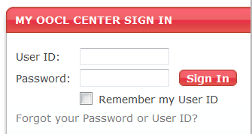

- Upon logging into your “My OOCL Center” select “Submit Service Request” under in the drop down menu under “Service Request”.
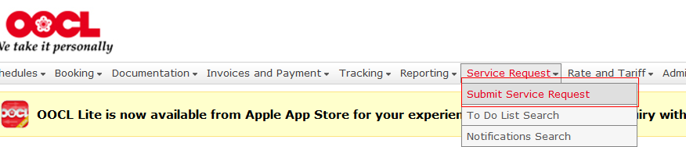

- Input your bill of lading number (no OOLU prefix required) and select “Search”.
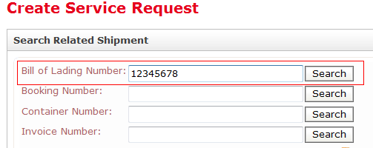

- Upon search results, select “Online” under Import Carrier Door Delivery Instructions.
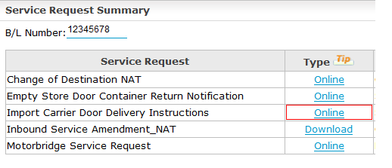

- OPTION 1 – Input Door Delivery Information and click “Submit”.
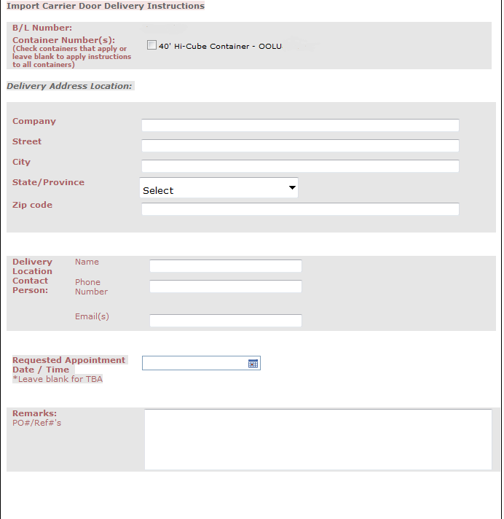

- OPTION 2 - Upload Delivery Instructions - If you already have delivery instructions in a word, PDF, or excel file, you can upload it by selecting the “Browse” button Select saved file Select Open and then “Submit”.
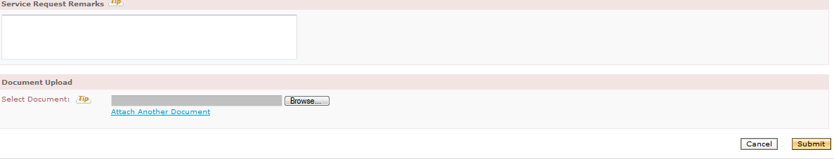

If you have any questions, please do not hesitate to contact Customer Service at 888-388-6625.

