OOCL e-Invoice Guideline
[Customer’s approaching]
- Receive e-Invoice via email:
- Customer will receive an email notification as attached sample.
- Customer click to the “code” to open the e-Invoice as below link and get the e-invoice:
- E-Invoice notification email:
- Click the code to open e-Invoice:
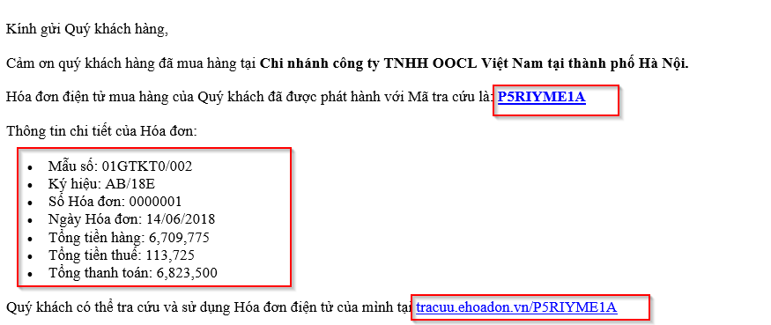
(c)E-Invoice will be display after click the “code”:
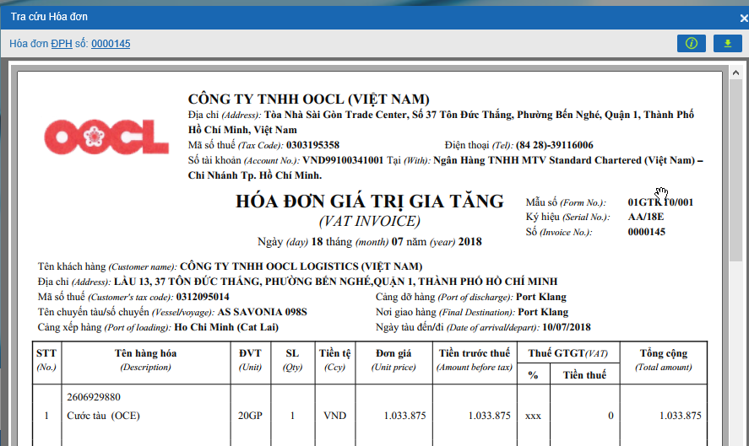

- Customer click as below screenshot to download e-Invoice:
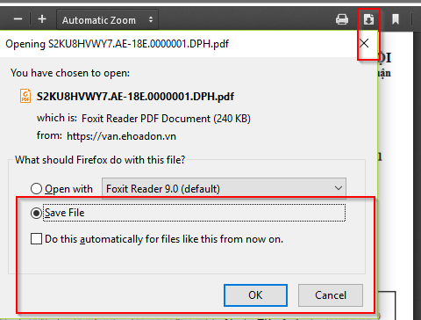
- Receive e-Invoice by account/password:

- Customer will be created an account with ID/password same as below:
(P/S: CCSV will send request to vendor if any customer account need to be created)
Username | Password
0312031455 | nUbgRGZkGGcXbu8aZWsx
0303195122 | lzkwohsmBVhKfU9WNdLU
3602482363 | 7Ujm3kBBpiNTVXFPSJQC

- Customer use ID/pass to link to BKAV’s website to log on and pick up e-invoice
- Link to receive e-invoice: https://van.ehoadon.vn/
- Log on via ID/pass:

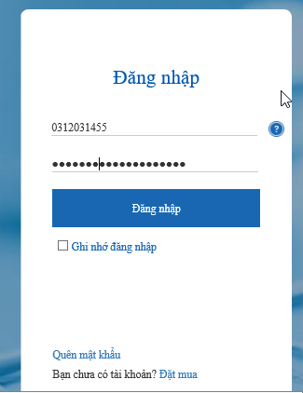

- The list of e-Invoice will be appeared for customer to review/receive e-invoice:

